**Introduction to JQuery**

**Date 11/02/2021**

1. **Console "Hello Word" in document.ready function.**

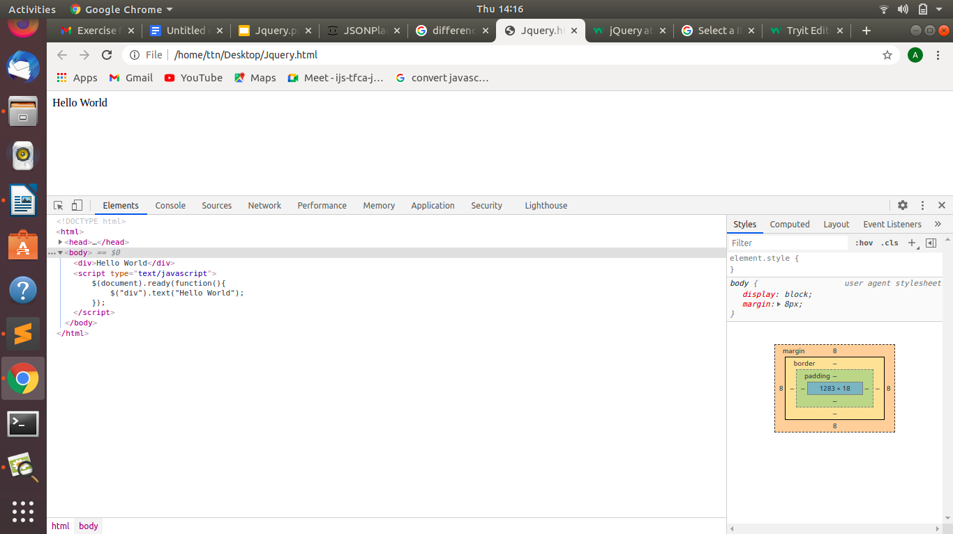

1. **Select a ID name "#test" and add class "load" when DOM is loaded.**

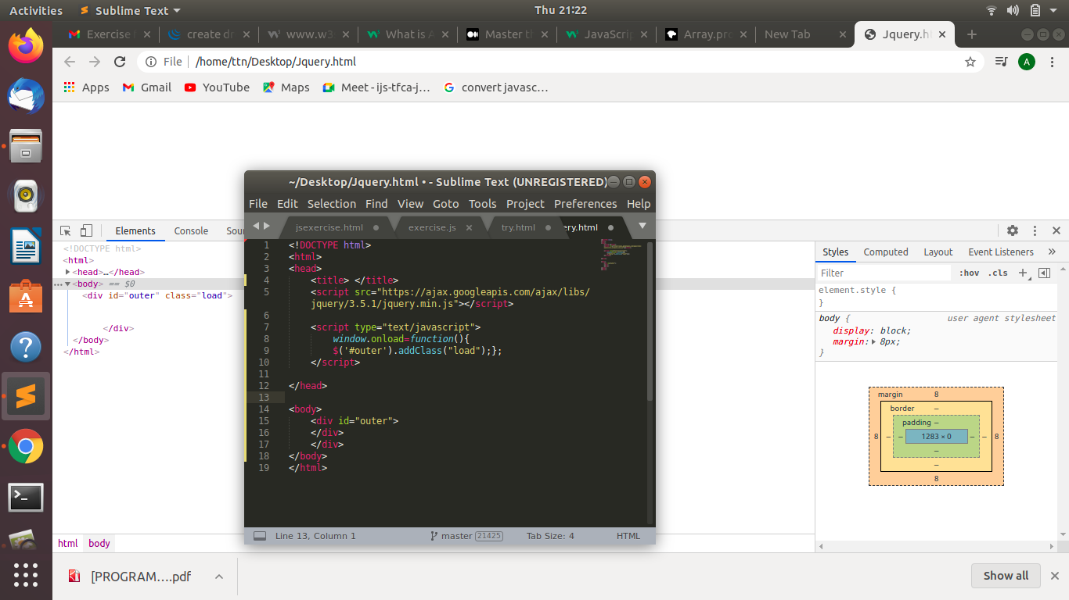

1. **Change the color of element which class name end with "-new".**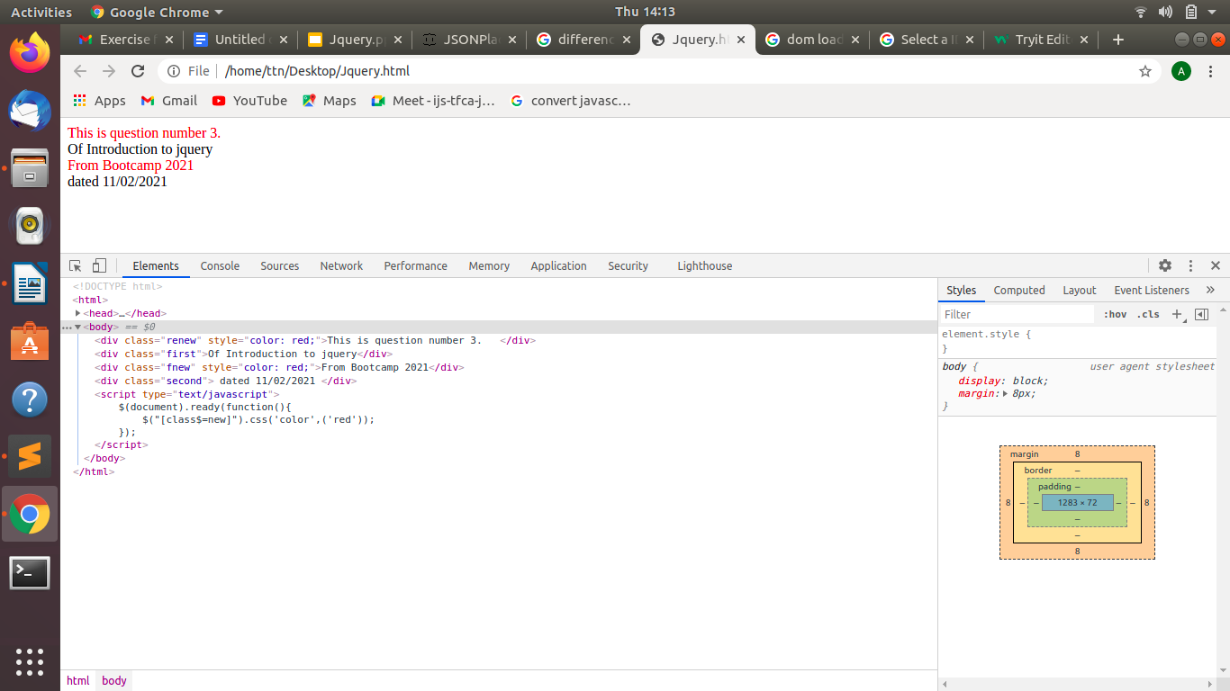
2. **Disable submit button using jquery attr method.**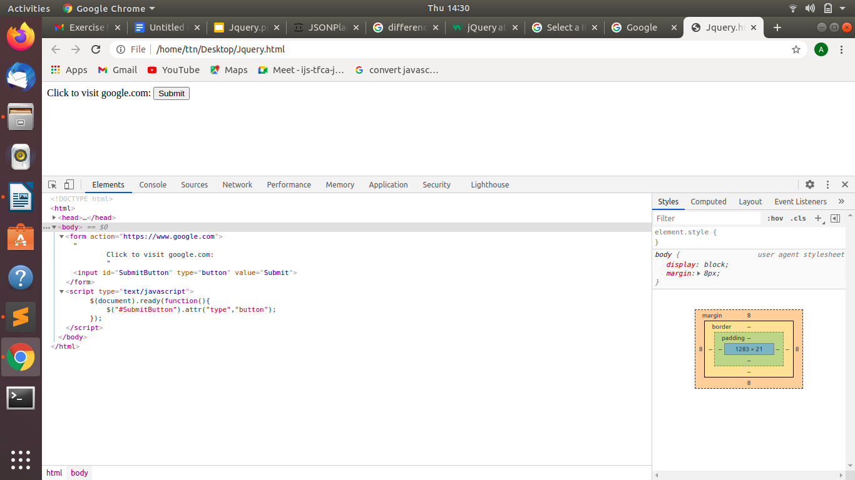
3. **Change the font size of ".target" which has parent element with id name "#main".**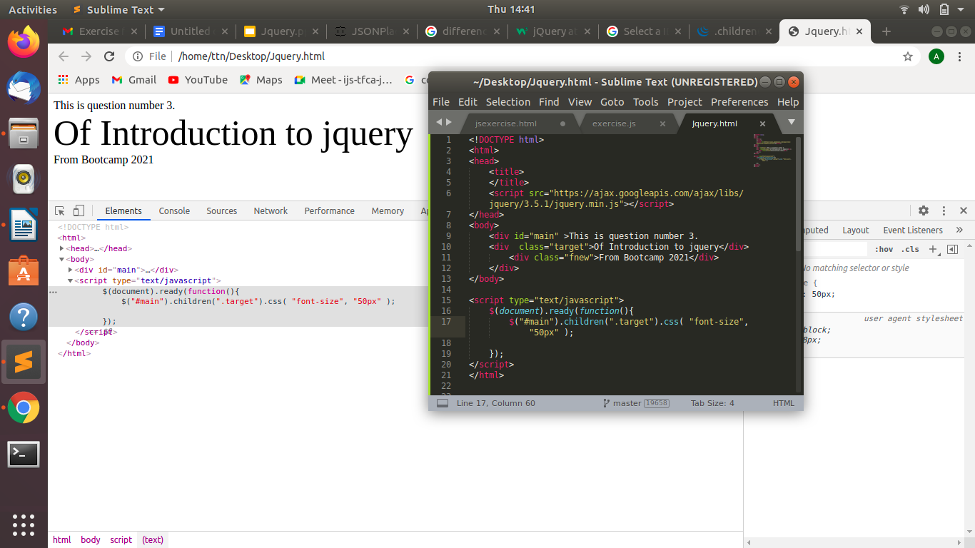
4. **After page load change the HTML of div element with "p" element**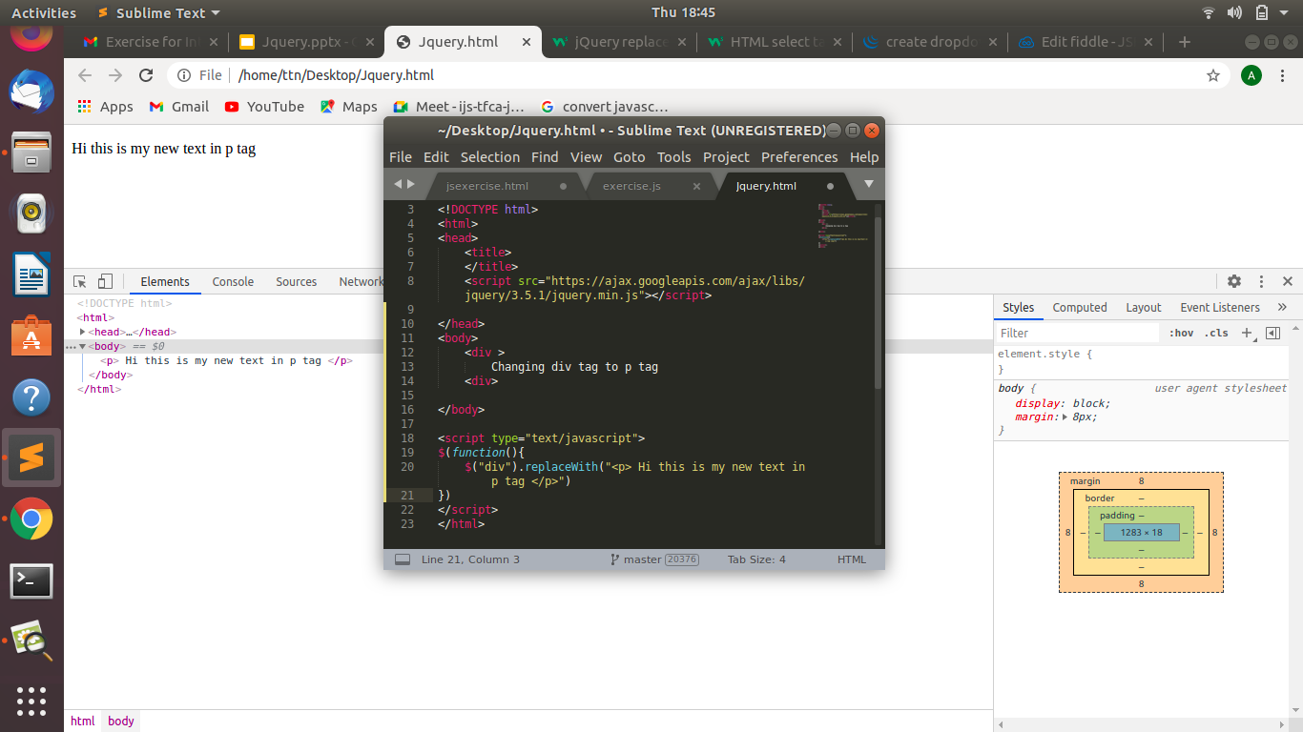
5. **Bind a click function to an "click" element and append next "click" next to it.**

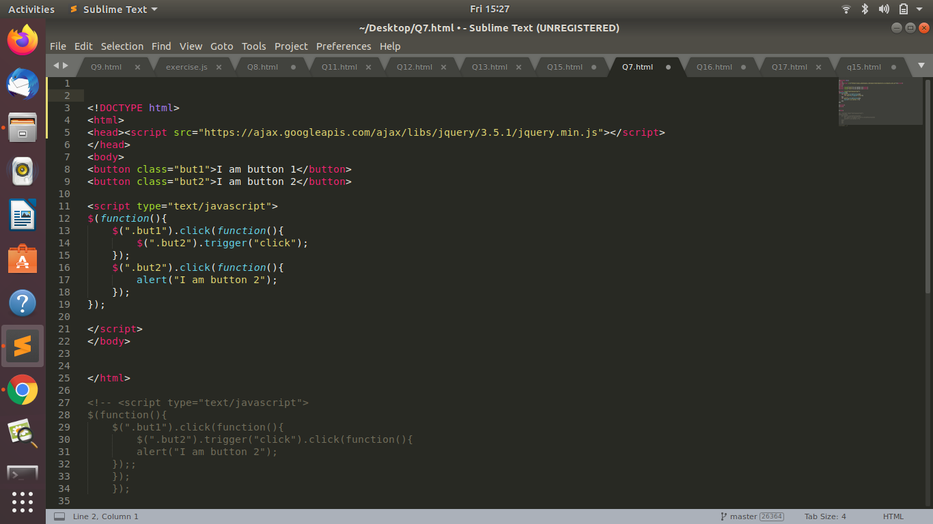

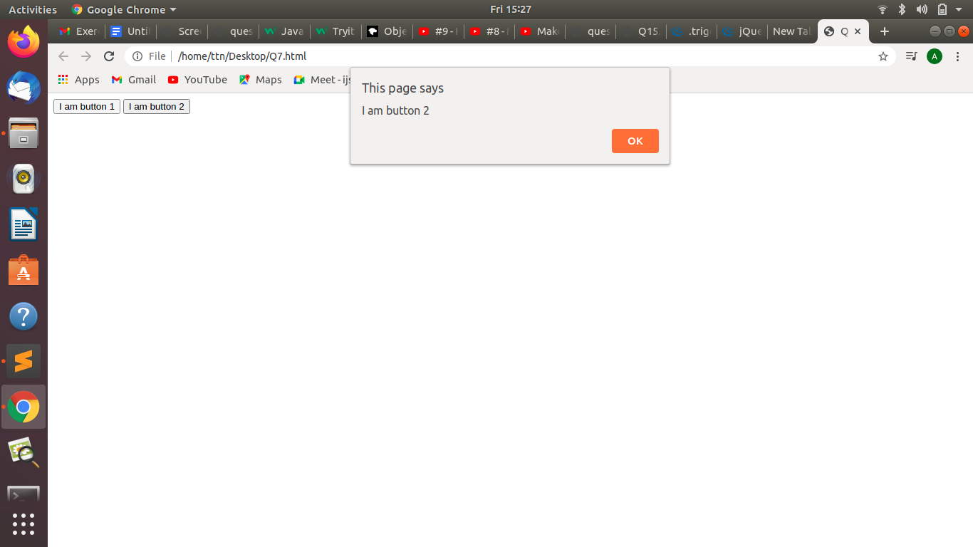

1. **Click event not working on element which added dynamicly or via script, make it work using .on method.**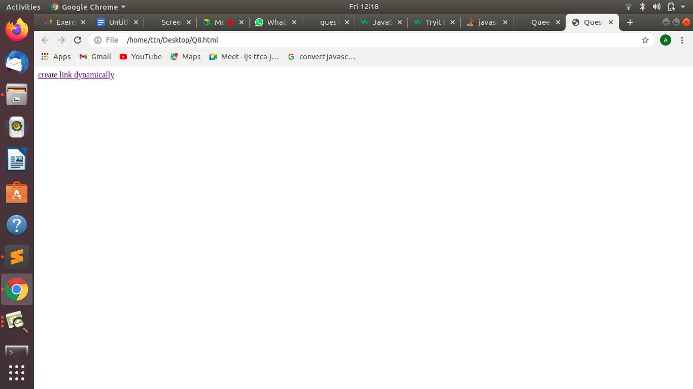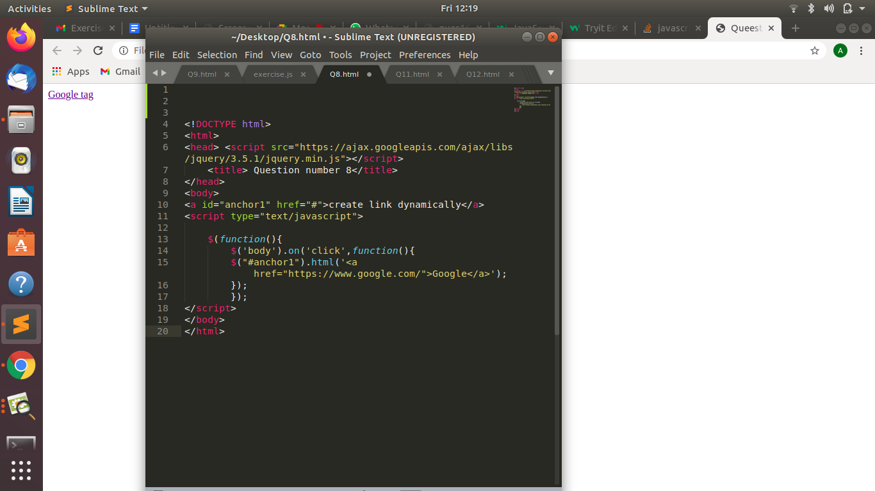
2. **Get dropdown selected value on onchanage event and append in div container**

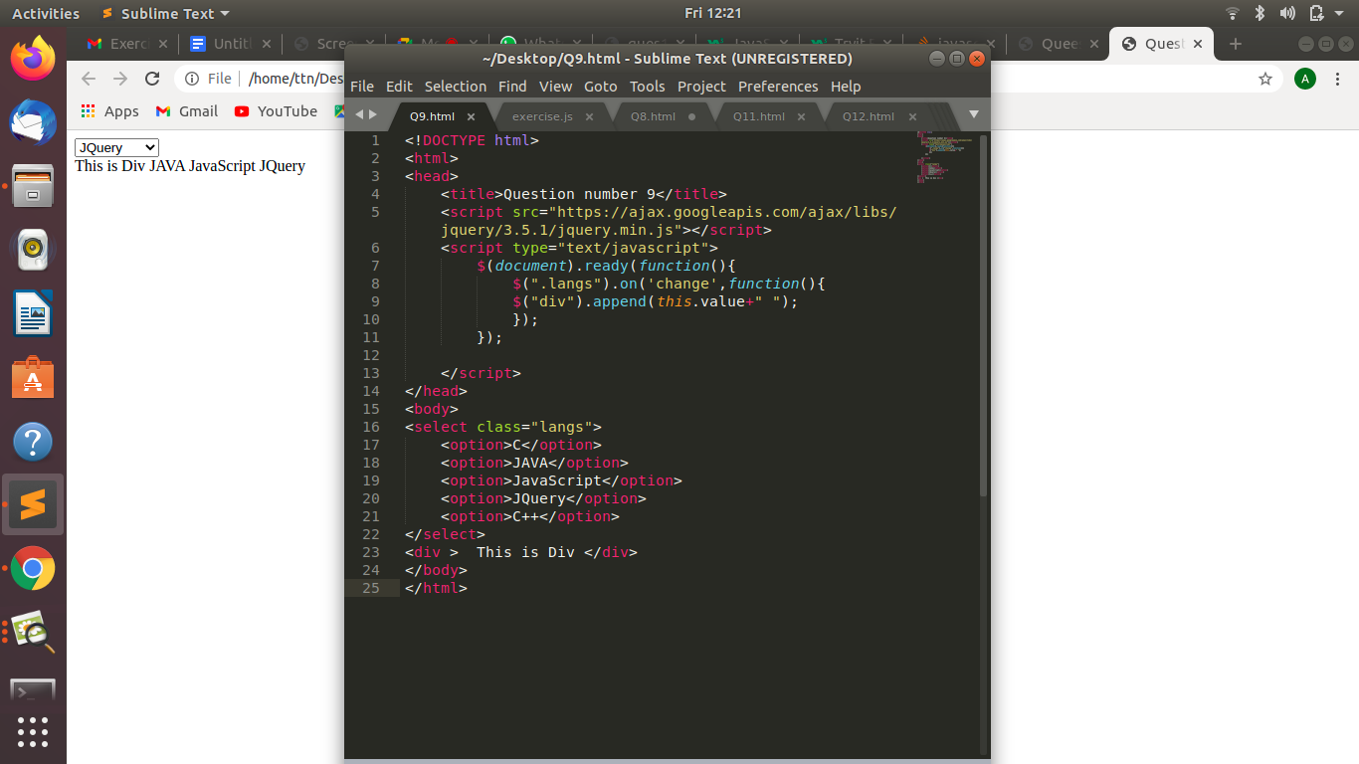

1. **Create a dropdown menu using hover method in jquery.**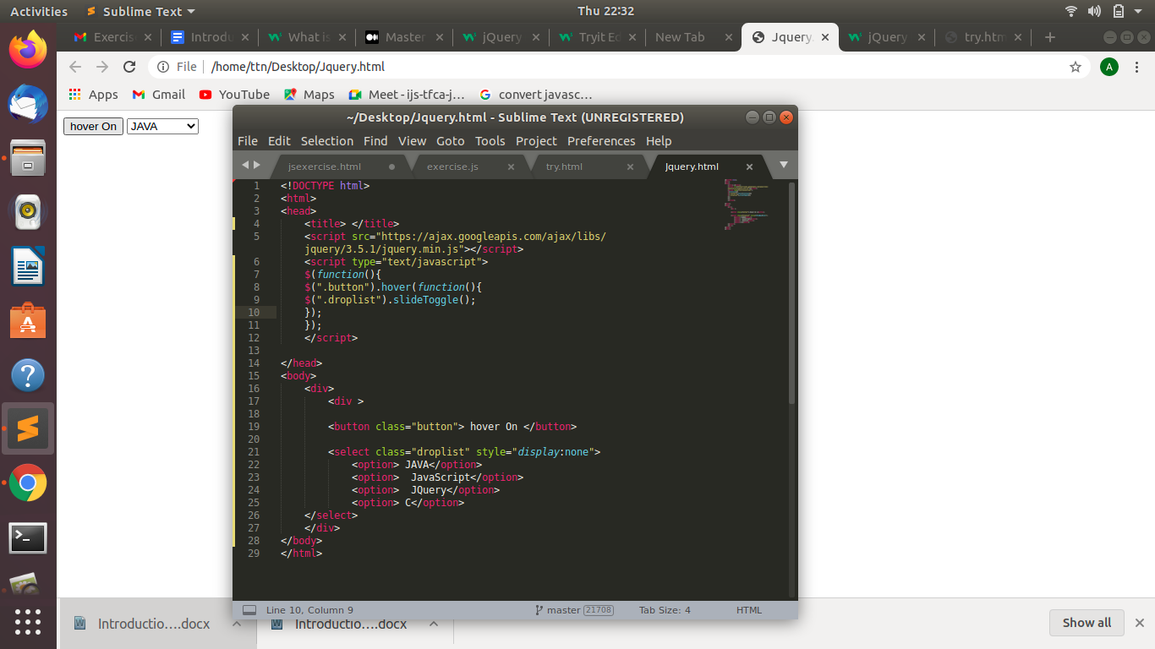
2. **On clicking on "**[**google**](https://www.google.com/)**" tag. It is taking us to google home page. Stop it from happening.**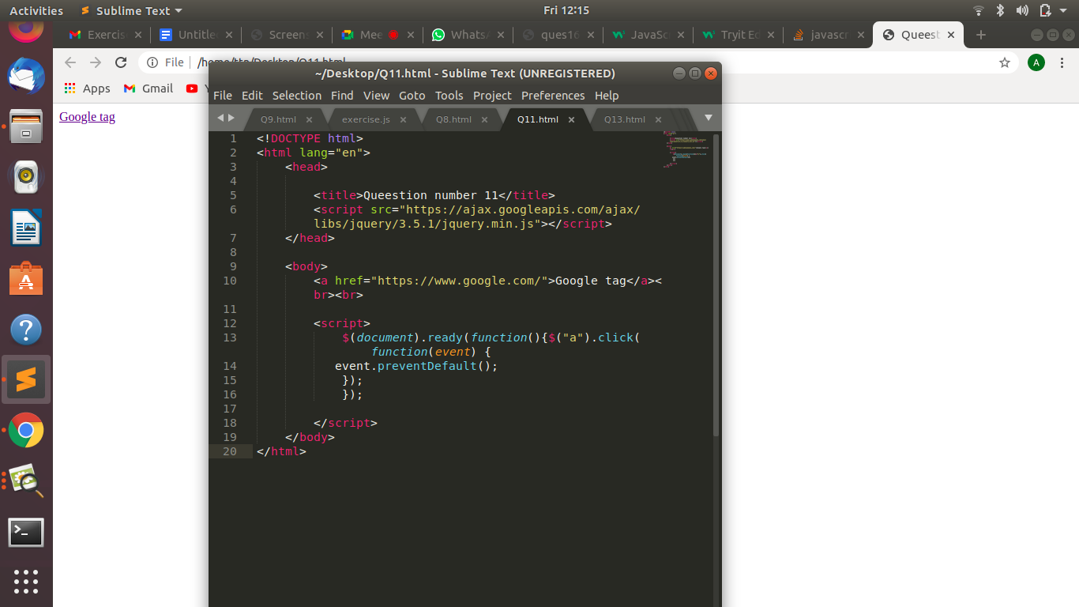
3. **We have bind a click funtion to parent div but we want stop it from performing when user clicks on its child li.**

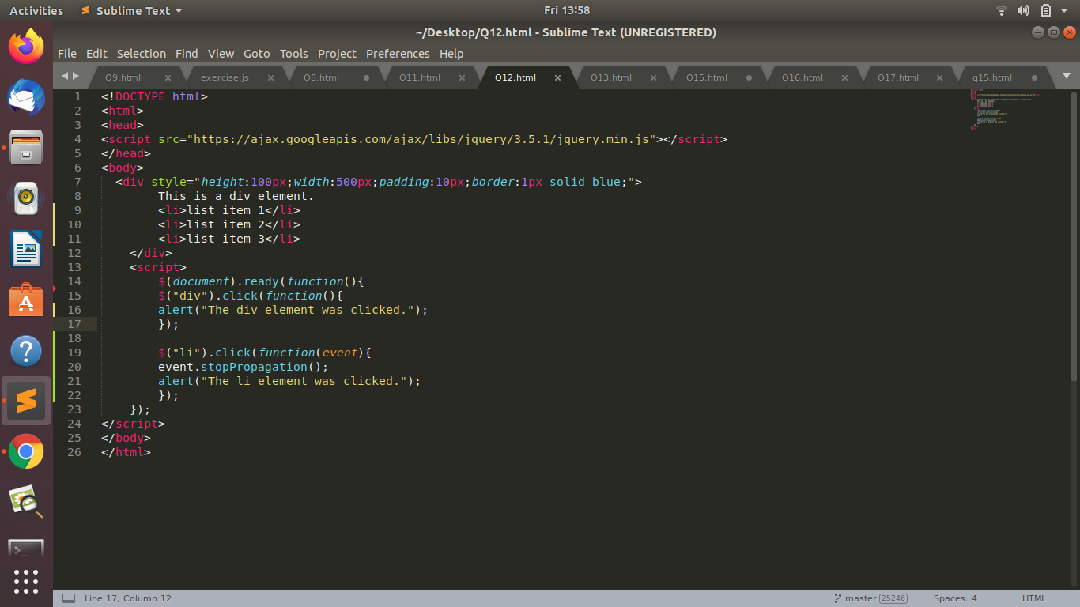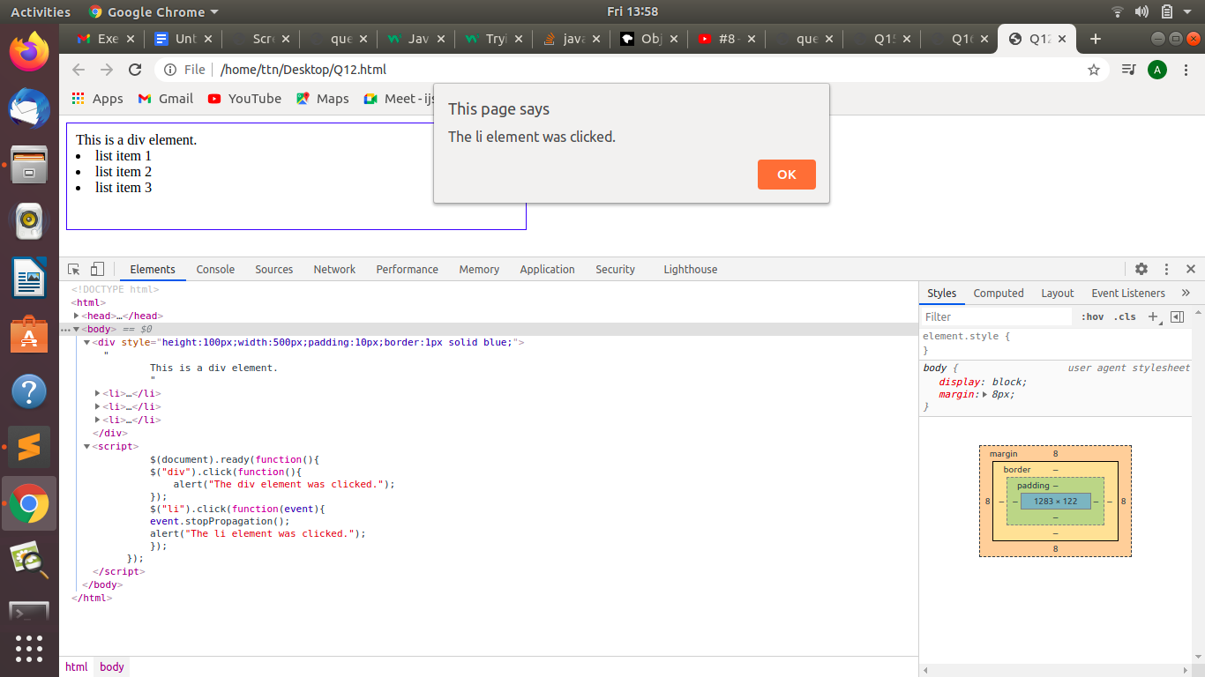

1. **Get the max height of elements using jquery each method**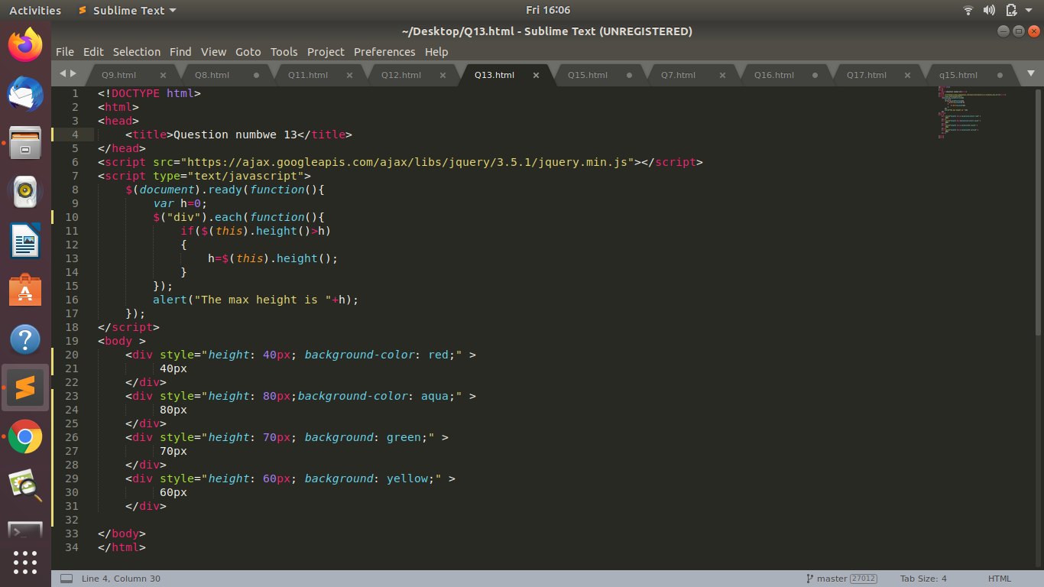

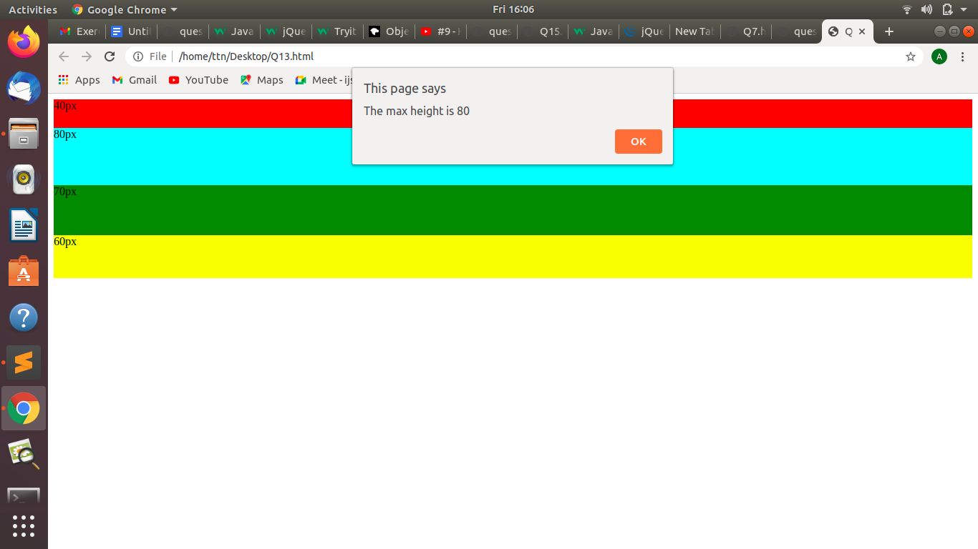

1. **Chagne color of every cell which has numberl larger than 10.**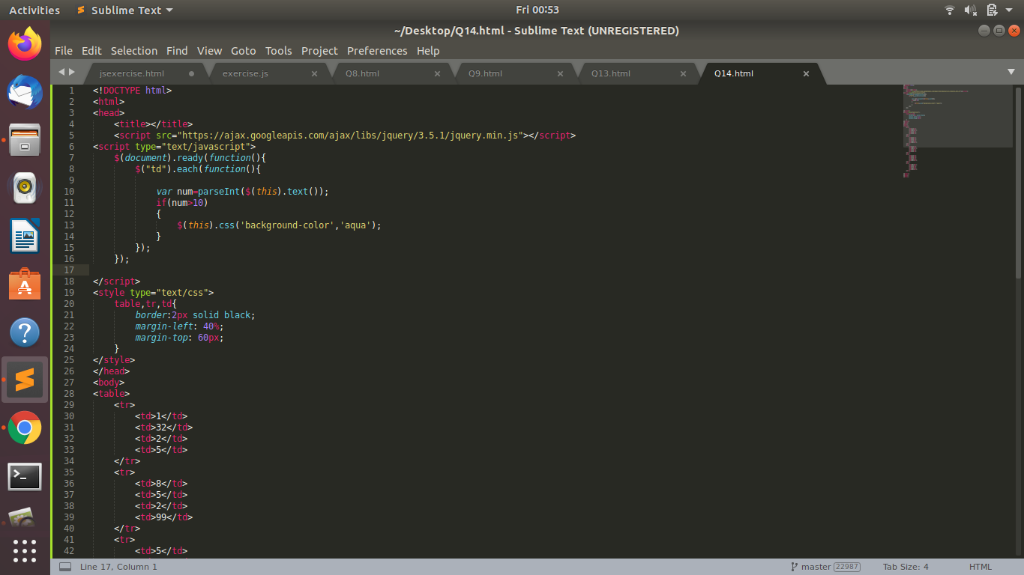

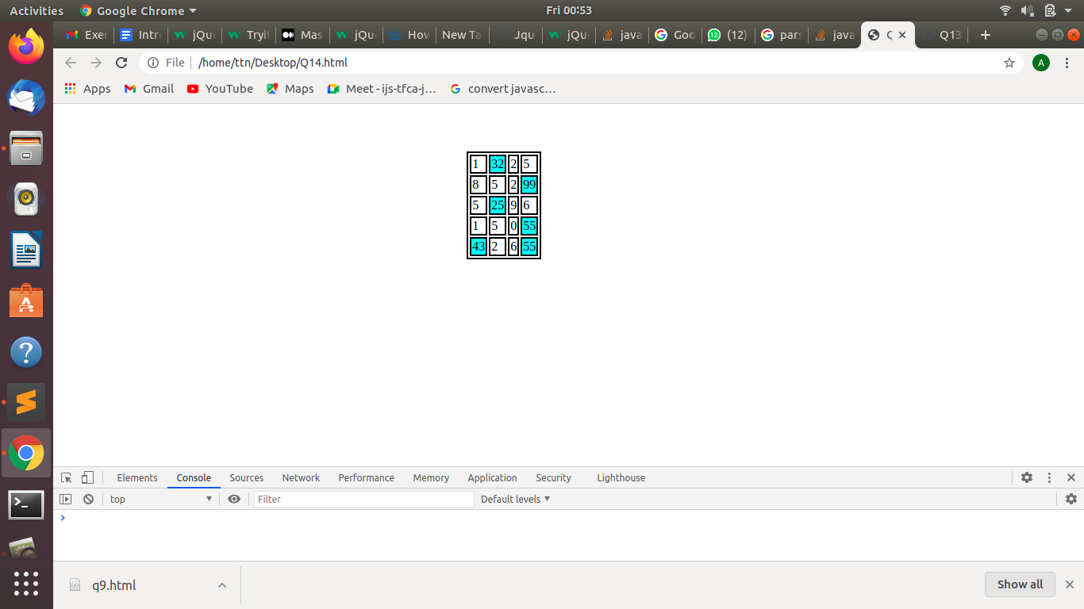

1. **Retrive the data from server using ajax get call**

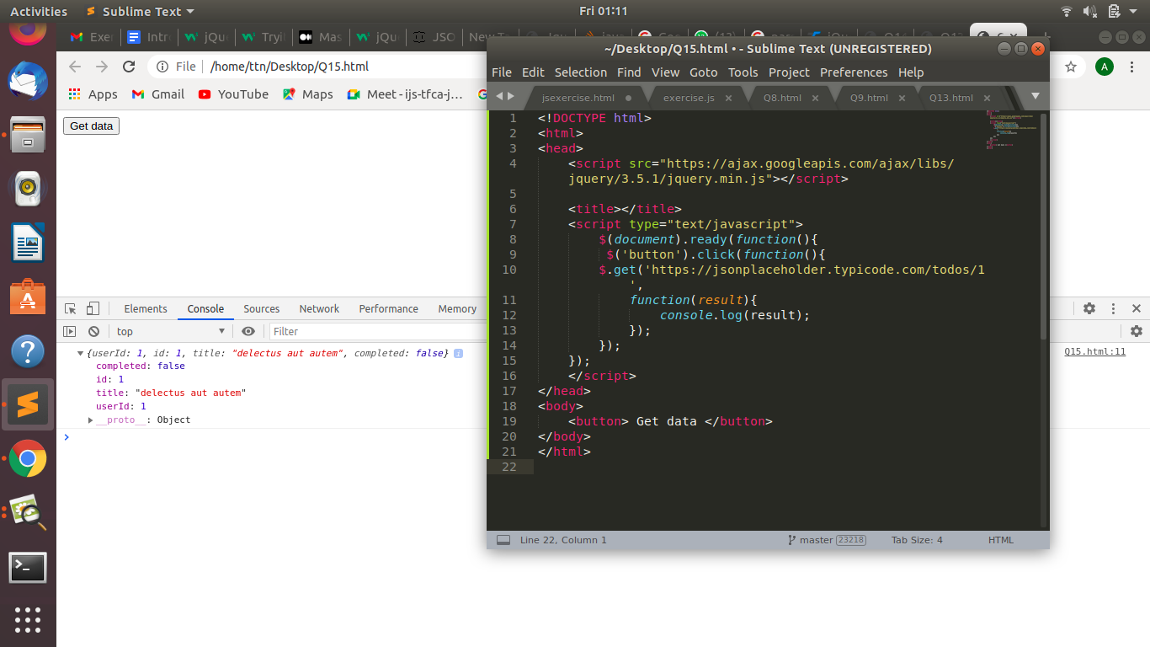

1. **Add cross button on row and bind click function which make a delete request to server, after success event remove the row from dom.**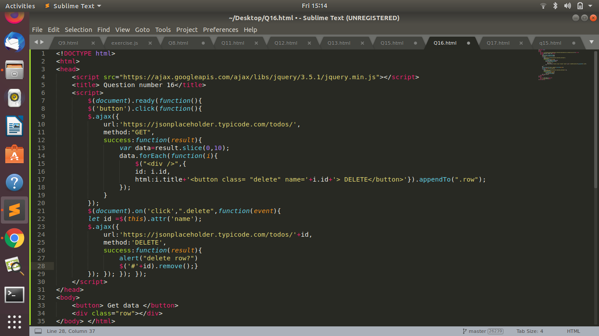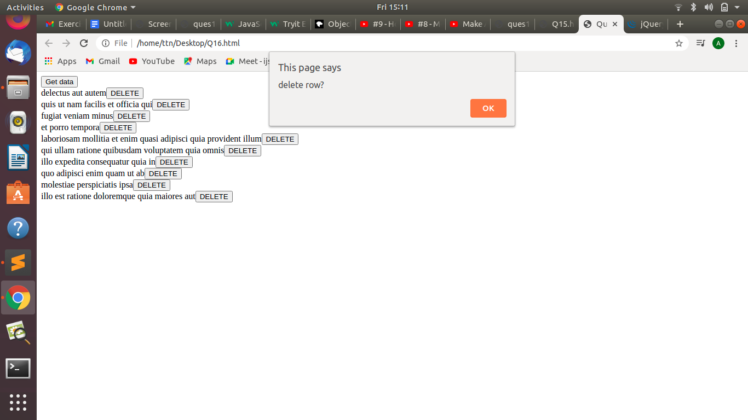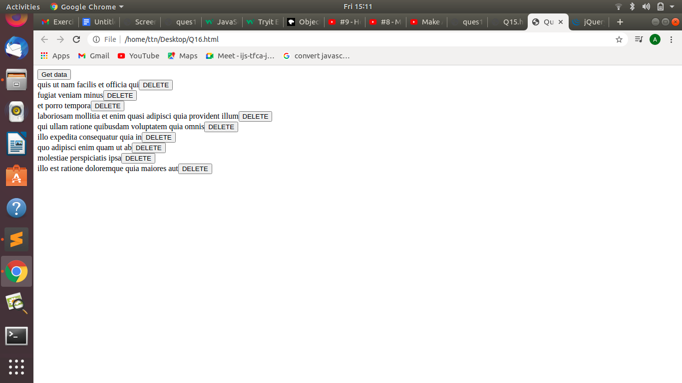
2. **Create a image array and in div create a slide show to animate images of delay of 500ms.**

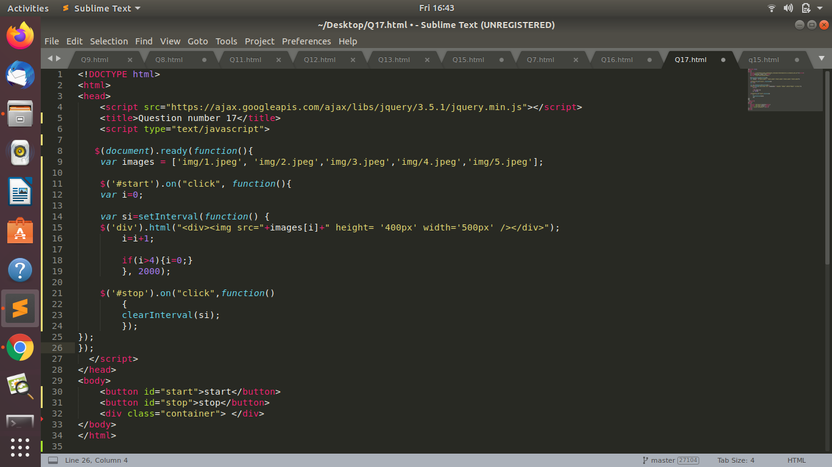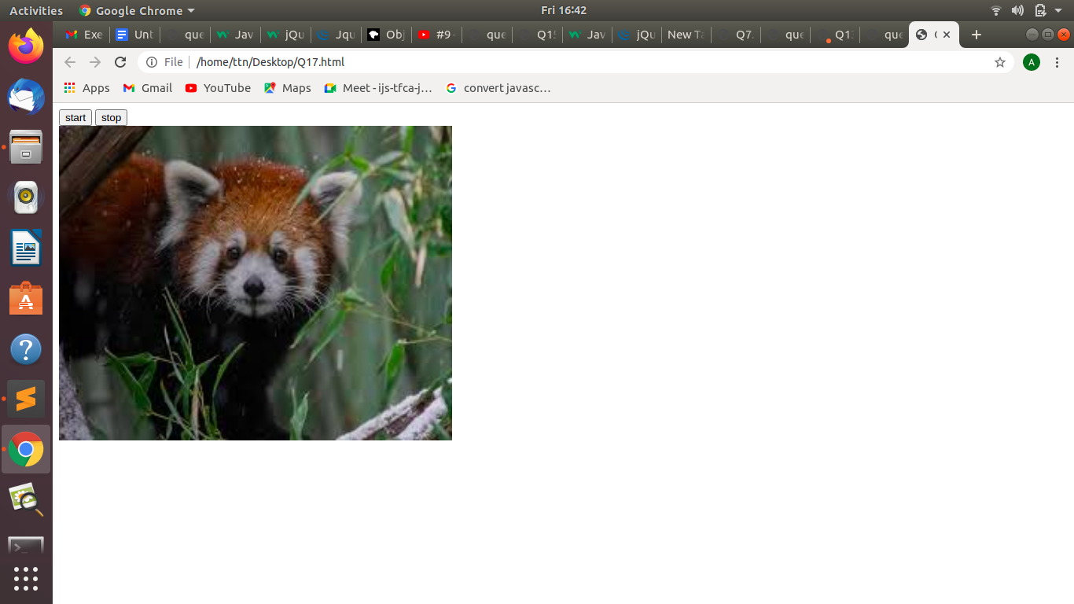

**Google doc link:** [**https://docs.google.com/document/d/1lvtum55QRLgbFC9UmmwrexnuzandWQ_97HJrBvPgn-E/edit?usp=sharing**](https://docs.google.com/document/d/1lvtum55QRLgbFC9UmmwrexnuzandWQ_97HJrBvPgn-E/edit?usp=sharing)